|  |
| --- |
|  |
| **Anti-Retroviral Dispensing Tool Installation Guide** |
| **(ADT)** |
|  |
|  |
|  |

|  |
| --- |
|  |

Table of Contents

Anti-retroviral Dispensing Tool (ADT) 1

1. System Requirements 1

1.1. Microsoft Windows 1

2. Installation Requirements 1

2.1 Chrome installation 1

2.2 Web server 2

2.3 Database Server 3

2.4 Htdocs 5

2.5 Migration Process 5

2.6 Required Software 7

2.6.1 Auto Backup installation 7

2.6.2 TeamViewer Installation 9

3 Additional software 10

3.1.1 Notepad installation 10

3.1.2 WinRAR installation 10

4 Errors you may encounter 11

4.1 Error 1 11

4.2 Solution 1 11

4.3 Error 2 12

4.4 Solution 2 12

5 System Migration and Testing 12

5.1 Migration Progress 12

5.2 Advanced Migration 13

5.3 Logging in 14

5.4 Ordering templates 14

# Anti-retroviral Dispensing Tool (ADT)

# System Requirements

Your computer system should conform to the following requirements for a successful installation:

## Microsoft Windows

* Windows XP, Windows 7, Windows 8/8.1
* At least 2GB RAM
* At least 2GB available disk spaces

# Installation Requirements

Here are the folders you require to install and set up ADT in your machine.

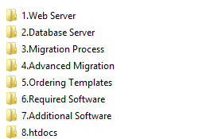

## Chrome installation

Skip this step if you already have chrome installed in your computer.

If you do not have chrome installed:

* Open the chrome portable folder in the Required Software folder.
* Double click on the ‘***google_chrome_installer_21.0.1180.79’*** to install.
* Go to settings to set it as the default browser.

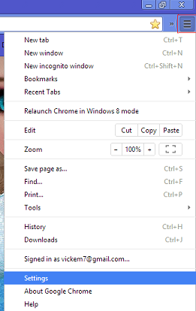 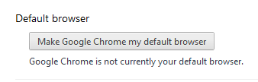

## Web server

This folder consists of xampp folder and a php file.

**Xampp Installation**

* Open the Xampp folder.
* Double click on ‘***xampp-win32-1.8.1-VC9-installer’*** file to start the installation. Follow the installation instructions.

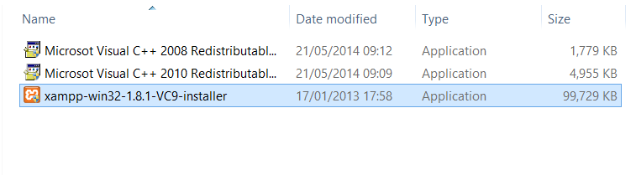

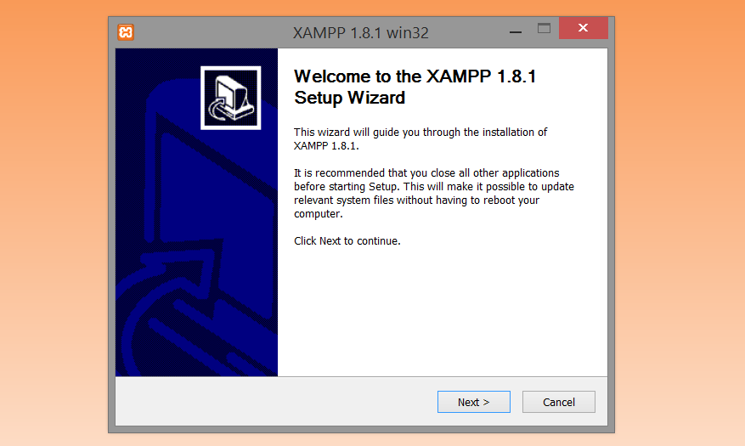

* When the installation is complete, a window will pop up prompting you to open xampp control panel. Click **YES** to open.

**Note**: Xampp control panel is an interface that allows you to start your xampp modules.

* Install the Apache and MySQL service. Windows security will alert you to **allow access** the servers on your local network.

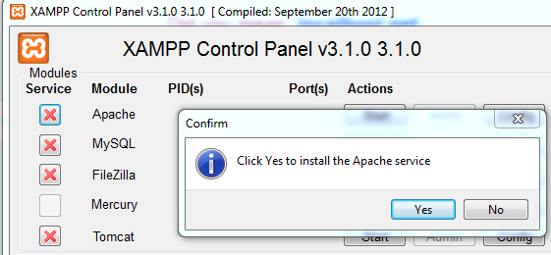 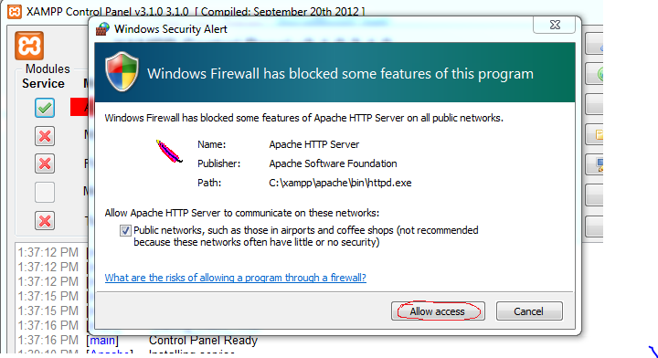

In case you encounter an error starting Apache service, you are required to change the administrative permissions as shown in the errors section, **Error 1.** Restart your computer after you are done.

* Click **start** button next to Apache and MySQL to start the module.

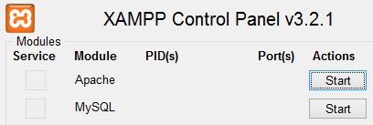

* After a few minutes, the PID/Port information will be displayed indicating that the module is running. The button will now be labeled **stop.**

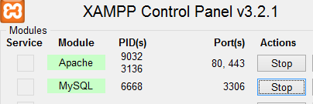

* Copy the ‘***php’*** file from the web server folder and paste it in C:\xampp\phpin your computer. Copy and replace the php file in the destination folder.
* Open chrome browser and type in http://localhost/xampp/
* Click security on the side menu.

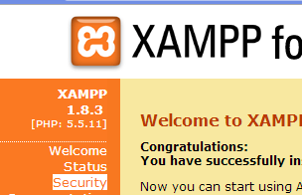

* Click [**http://localhost/security/xamppsecurity.php**](http://localhost/security/xamppsecurity.php) in the security page
* Set ‘**root**’ as the password and click password changing button.

## Database Server

This folder has the ‘***defaultadt.sql*** ‘file.

* In your type in http://localhost/phpmyadmin/
* You will be prompted to log in. Enter ‘root’ as your password.

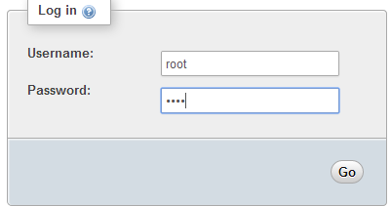

* Click databases on the menu
* Create a database named ‘**testadt’**

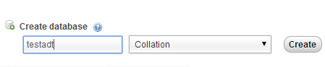

* In the list of databases, click testadt.

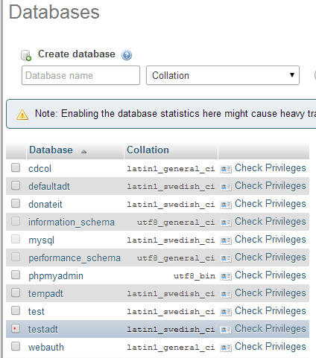

* Click import on the menu.
* Click the ‘Choose File’ button to select the ‘***defaultadt.sql***’ file in the database server folder.

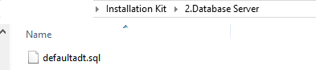

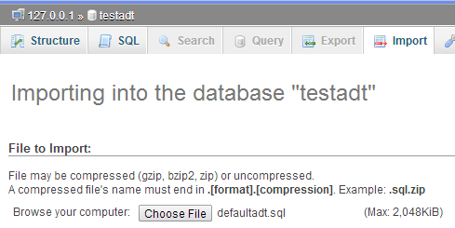

* Once the file uploads click ‘GO’ at the bottom of the page. Wait for importation to complete.

## Htdocs

This folder has ADT and UPDATE folders. Copy the two folders in C:\xampp\htdocs.

## Migration Process

* Open the ESF Database Migration Toolkit.
* Double click on the ‘***esf_dbcv_pro’*** file to start the installation. Follow instructions.

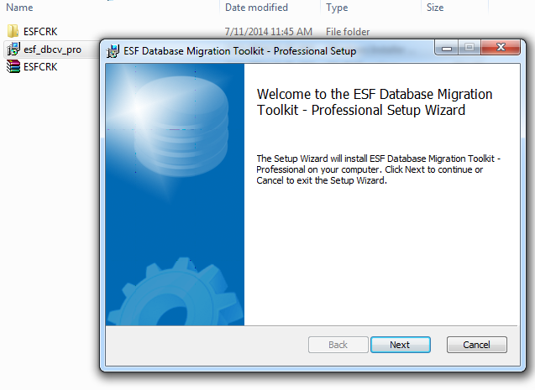

* Open ESFCRK folder and copy the ‘***cvdb.dll’*** file and the ‘***esfdbcv’*** application***.***
* Open the EasyFromTrial folder in C:\Program Files (x86). Paste the ‘***cvdb.dll’*** file and the ‘***esfdbcv’*** application.
* Create a new database named ‘**tempadt**’.

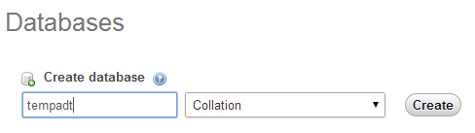

* Open the ESF Database Migration Toolkit application on the desktop and click next
* Choose a data source. Select ‘Microsoft Access’. Click the button next to the database field to choose the ARVDatabase from the location it is stored in. Click next.

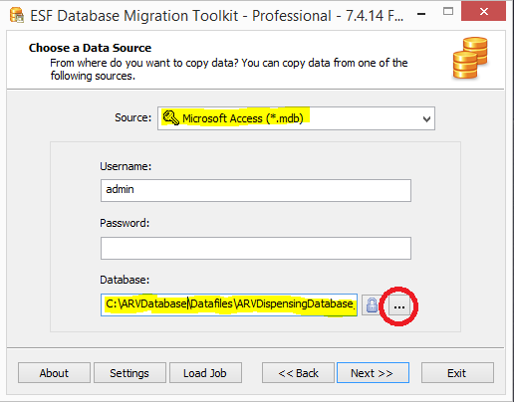

* Choose a destination. Select ‘MySQL Database’.
* In the password field type your localhost password, that is, ‘root’. This allows access to your list of databases.
* Select ‘tempadt’ from the list as your database. Click next.

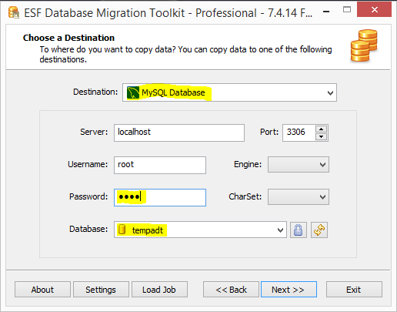

* Select all tables and click next.

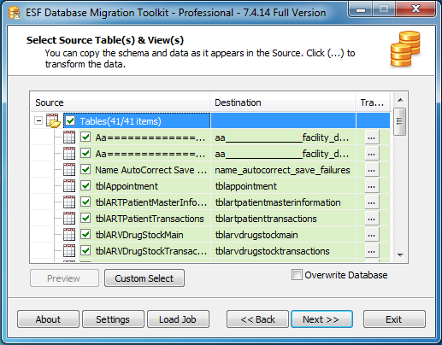

* Click the submit button to start migration. Close when migration is complete.

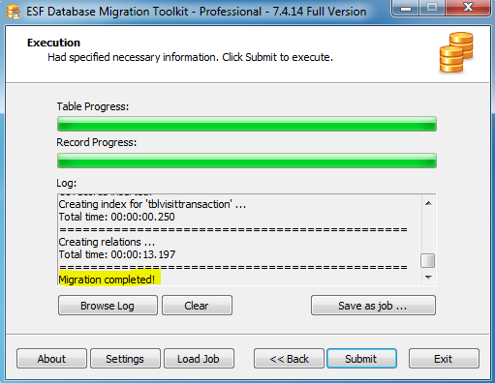

## Required Software

### Auto Backup installation

* Create a folder on your desktop. Name it ‘webadt backup’.



* Open the Auto Backup folder to access **‘*abmprofullc*’** setup.
* Double click on the setup and follow instructions.

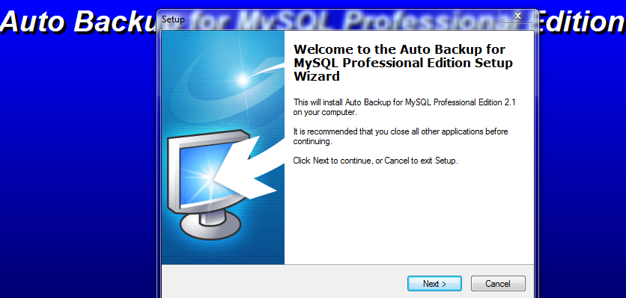

* Click the ‘enter registration’ button.
* Open the serial file in the Crack folder.
* Copy and paste the username, user email and the license code in the respective fields.

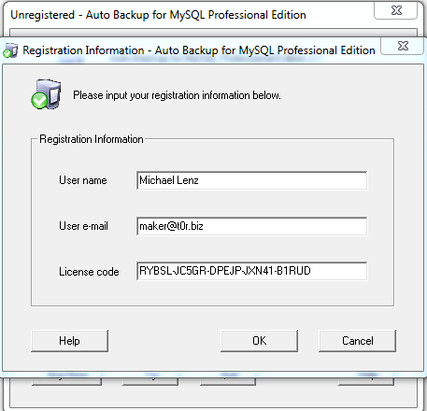

* Click the ‘create task’ button.
* Type in the task name ‘webadt’. Click next.

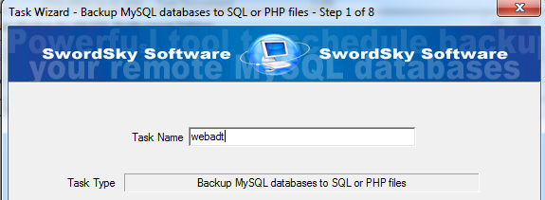

* In the password field, type ‘root’. Click next.
* Check testadt as your database. Click next.

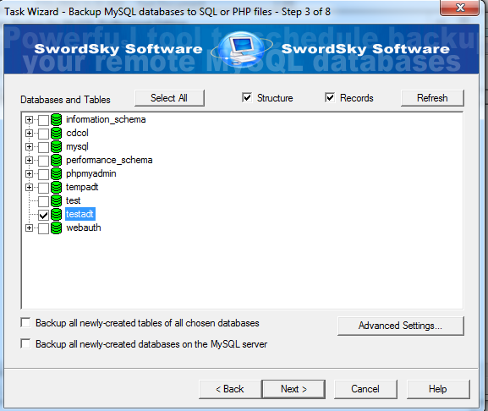

* Check ‘compress a SQL backup file’ in the compress options. Click next
* Check ‘use buffer mode’. Click next.
* Select ‘Everyday’ on task schedule. Change settings to the time of your preference.

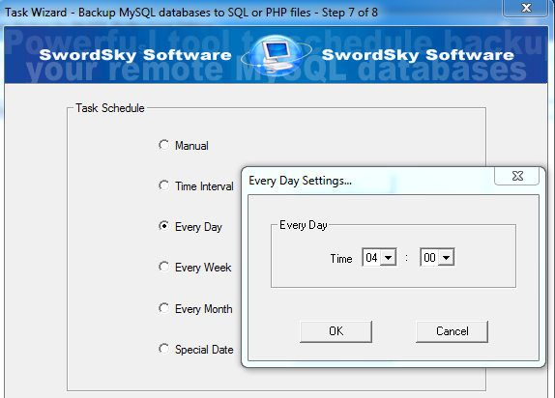

* Finish and minimize the window.

### TeamViewer Installation

* Double click ***‘TeamViewer_Setup’*** to start installation.
* Select ‘Personal/Non-commercial’.

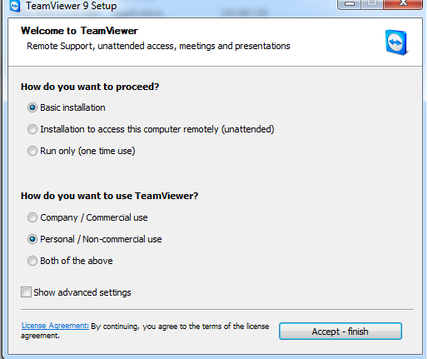

* Click ‘Accept-finish’ button. Click **YES** to continue with the installation.
* On the menu, click connection and select ‘Setup unattended access…’ option. Click next.

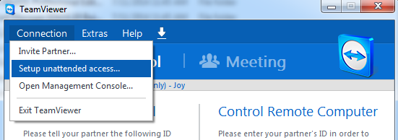

* Type ‘webadt_2014’ in both password and confirm password fields. Click next.
* Select ‘I don’t want to create a TeamViewer account now’. Click next.
* Finish.

# Additional software

### Notepad installation

* Double click ***‘notepad++.6.1.5.Installer’*** to start installation.

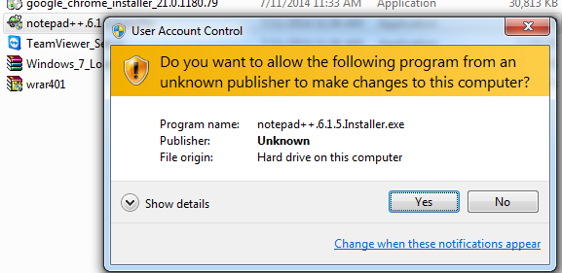

* Follow the instructions for a successful installation.

### WinRAR installation

* Double click ***‘wrar401’*** to start installation.

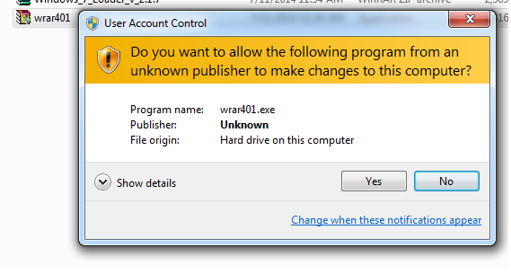

* Follow the instructions for a successful installation.

# Errors you may encounter

These errors are encountered during the installation of Xampp.

## Error 1

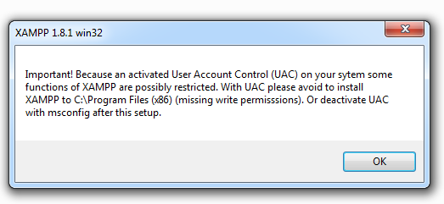

This results from administrative permissions.

## Solution 1

To change these permissions:

* In your search bar, search for user account control.
* Lower the scale from the current level to a lower level.

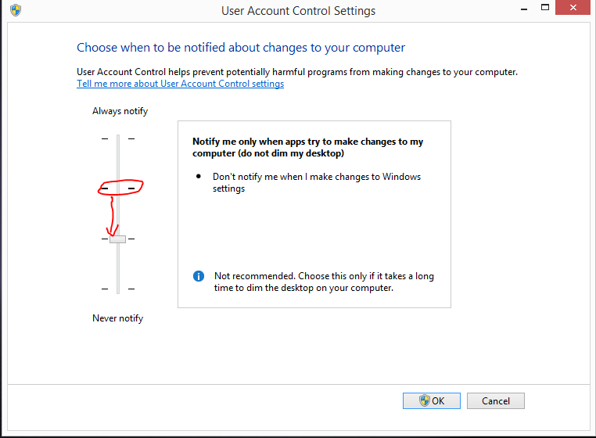

Click **OK** to continue with the installation.

## Error 2

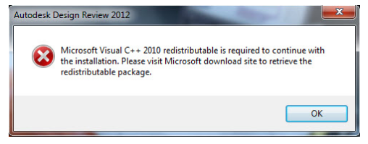

This error results from the absence of Microsoft Visual C++ redistributable package needed to start Apache.

## Solution 2

Close the window and continue with the installation of Xampp. On completion, install the redistributable package in the xampp folder.

* Double click ***‘Microsoft Visual C++ 2008 Redistributable package’*** to start installation.

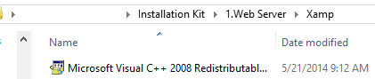

* Follow the instructions for a successful installation.
* Restart the computer.
* Run the xampp control panel and start Apache as a service.

# System Migration and Testing

## Migration Progress

* On your browser, go to url http://localhost/ADT
* Login using the following credentials:
  + Username: sysadmin
  + Password: marete123
* Click the migration from the menu

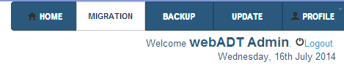

* In the migration settings:
  + Select the facility name of the facility you installed the system
  + Select ‘main pharmacy’ in the pharmacy section
  + Select the ‘tempadt’ for database
  + Select the tables you want to migrate from the tables list

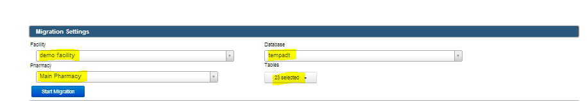

* Click the **start** button to start the migration. You will see the progress of migration from the ‘overall progress’ bar.

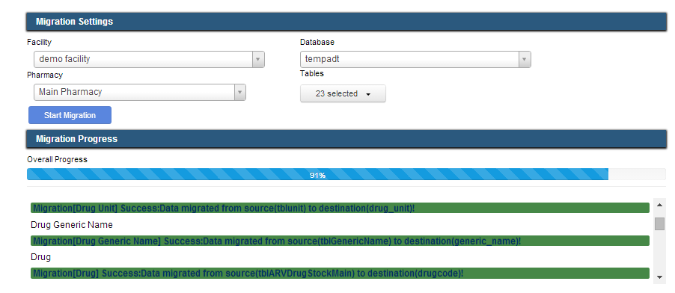

* When migration is complete, logout



## Advanced Migration

This process is only used when the facility’s drug_stock_movement data is large. Carry out the migration as explained in the **migration progress**. Instead of selecting all tables in the migration settings, select all other tables apart from the drug_stock_movement table.

Follow the instructions in the advanced migration file. Open the advanced migration folder to find the file, follow the instructions inside.

## Logging in

* Login to the main system using the following credentials
  + Username: kmarete
  + Password: marete123
* You can also login using the credentials from the access ADT
* You should now view the name of the facility like in the case of ‘demo facility’ and all its information.

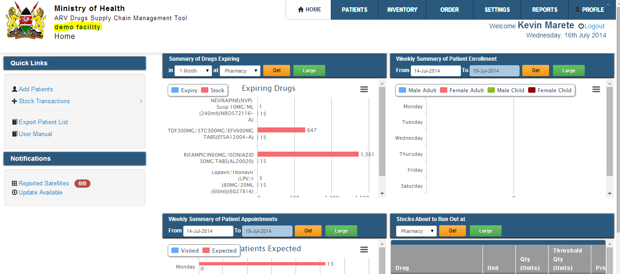

Installation is completed and the system is ready to use.

## Ordering templates

This folder has two excel files, the ‘***F-CDRR for Satellite Sites’*** and ‘***F-MAPS for Satellite Sites’.***  These files are used by the satellite facilities. They should be given to the facility to distribute to their satellites.

